(Product mix) Croscill Home is a leading seller for classic luxury bedding, bath and window collections in United States. Company manufactures various designs of bedsheets, curtains and cushion cover. Company can easily manufacture all 3 items out of the same cloth print and sell to the customers. For current month, company has a cloth print of 1,000,000 square inches each with cost of $0.01 per square inch. 1 Bedsheet requires 39*75 square inches of cloth, 1 curtain requires 82*84 square inches of cloth and 1 cushion cover requires 16*16 square inches of cloth. As per the customer demand in market, minimum 10 curtains need to be produced and number of bedsheets should be at least twice the number of cushion covers produced. Each bedsheet is sold at $70; each curtain is sold at $180 and each cushion cover is sold at $40. What should be the optimal number of bedsheets, curtains and cushions to be produced by company given the business constraints.
Discussion: -
The Objective over here is to decide the optimal number of bedsheets, curtains and cushion cover for Croscill home such that the company is able to achieve maximum profit while meeting all its constraints. The input parameters for this problem are squared inches of cloth required to produce 1 unit of each item type i.e. bedsheet(39*75), curtain(82*84) and cushion cover(16*16), selling price for each item[$70, $180, $40] total cloth available with company and cost per squared inches of cloth to the company($0.01).
Since we need to decide the optimal number of bedsheets, curtains and cushion covers to produce, so our decision variable is how many of each of these to produce.
Next the objective is to find the maximum profit which will be the difference between total revenue after selling and total cost incurred by the company for manufacturing the number of items as given by decision variable.
The profit should be maximized given the constraints that total cloth available for producing different items is limited (1,000,000 squared inches). As per customer demand, minimum number of curtains to be produced is restrained (10) and number of bedsheets to be produced should be greater than or equal to twice the number of cushions to be produced.
Now we are clear with input parameters, decision variable, objective function and constraints, we can write our mathematical model and consequently set up in excel to solve using excel solver.
Mathematical Model: -
Parameters (Inputs):
$$i ϵ 1,2,3 \left( Index for items; 1=Bedsheets, 2=Curtain,3=Cushion cover\right)$$
$$T :Total square inches of cloth available for production for the month$$
$$C :Cost of cloth per square inches$$
$U_{i} :Units of cloth used in square inches to produce item type i$
$${SP}_{i} :Selling price of 1 item type i$$
$$T :Total square inches of cloth available for production for the month$$
$$C :Cost of cloth per square inches$$
$$M :Minimum number of curtains to be produced$$

Decision Variables:
$$x_{i} :Number of item type i to be produced by Croscill Home$$

Objective:
$$Max Total Profit= Total Revenue-Total Cost$$
$$Max Total Profit= \sum_{i=1}^{3}{(x_{i}*{SP}_{i})}-\sum_{i=1}^{3}{\left(x_{i}*U_{i}\right)}*C$$

Constraints:
$$x_{i}≥0; \left(1\right) Non Negative decision variable$$
$$\sum_{i=1}^{3}{(x_{i}*U_{i})} ≤U \left(2\right) Total Cloth availability$$
$$x_{2} ≥10 \left(3\right) Minimum number of curtains to be produced$$
$$x_{1} ≥2*x_{3} \left(4\right) Minimum number of bedsheets is atleast 2*cushion cover$$
Total cloth that can be used is limited and the last 2 constraints are based on market condition for this industry.

Excel Implementation:
Please find the attached spreadsheet for solution.
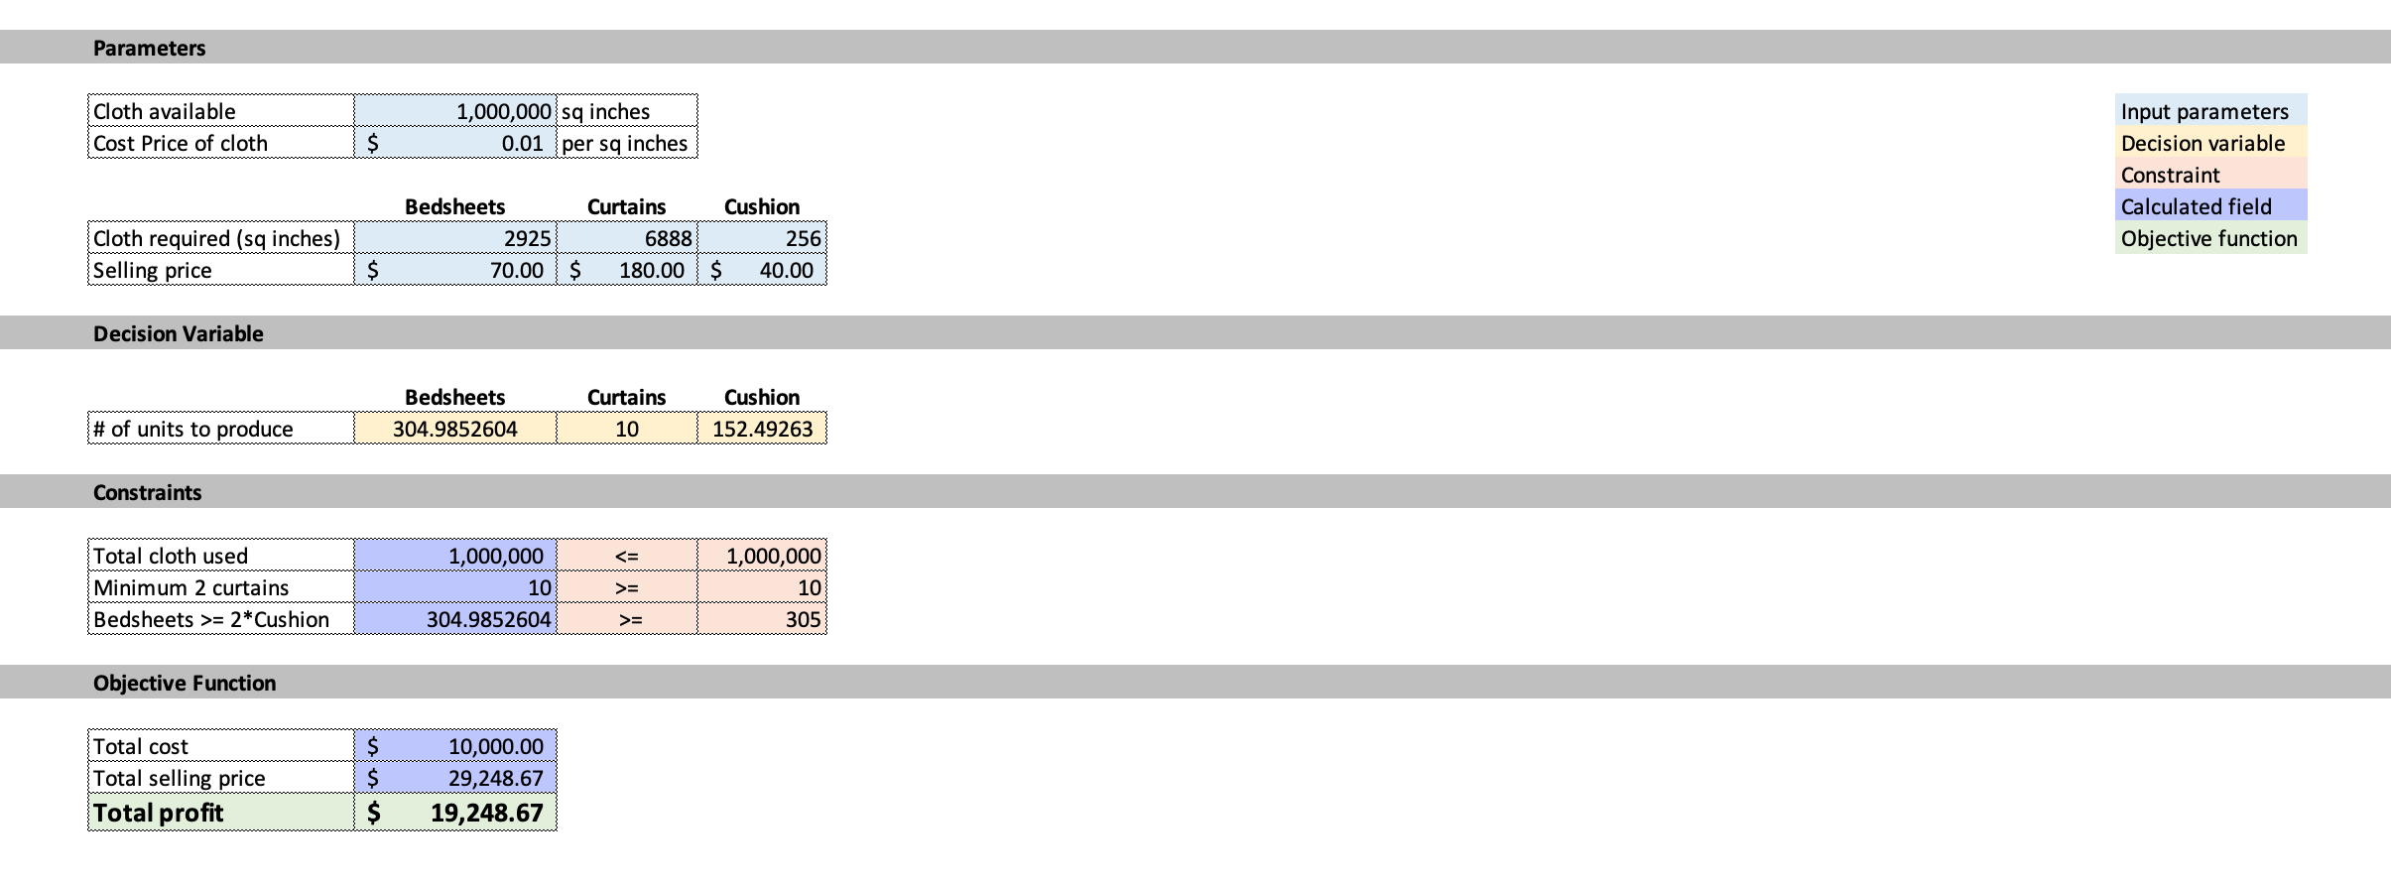
As per the optimization model company can produce 304 units of bedsheets, 10 curtains and 152 units of cushion covers to get the maximum profit.
Solver’s sensitivity report performs two types of sensitivity analysis:
- On the co-efficient of the objective (coefficient of Bedsheets, curtains, cushion covers)
- On the right sides of the constraints (3 constraints as mentioned above)
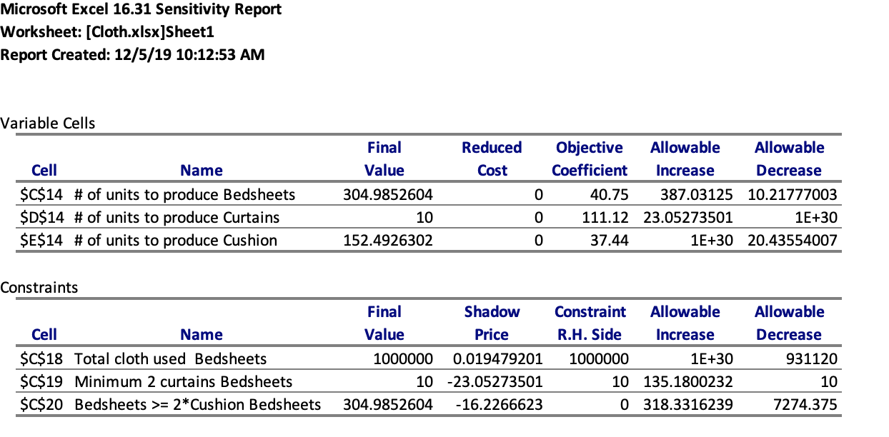
In the variable cells table, we can see final profit coefficient for 1 unit of bedsheets, curtains and cushion cover along with the allowable increase and decrease in this profit coefficient before the optimal solution changes. It means that if we increase profit coefficient for bedsheets by 387 or decrease by 10.2, the optimal solution will remain unchanged i.e. 304 units of bedsheets, 10 curtains and 152 cushion covers. Similarly, we can interpret for curtains and cushion covers.
In the constraints table, we can see the shadow price which indicates how much the objective function will change for every 1-unit change in the constraint given the change happens within allowable range as mentioned by allowable increase and decrease. It means that if we increase the minimum number of curtains constraint from 10 to 11, then the final profit will decrease by $23.05 i.e. $19,271.73. This will continue to happen till allowable increase (135) and allowable decrease (10). Similarly, we can interpret for other constraints.

